**Subject:**

TC4002 - Analysis, Design and Construction of Software Systems

**Professor:**

Gerardo Padilla Zarate

**L3.1 - Development Exercises**

**Student:**

Juan Francisco Corral Stenner A00354823

16) Given the math.ceil function,

- Define a set of unit test cases that exercise the function (Remember Right BICEP)

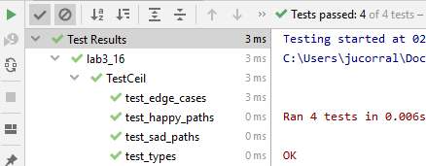

**17) Given the math.factorial function,**

**Define a set of test cases that exercise the function (Remember Right BICEP)**

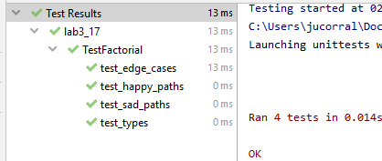

18) Given the math.pow function,

Define a set of test cases that exercise the function (Remember Right BICEP)

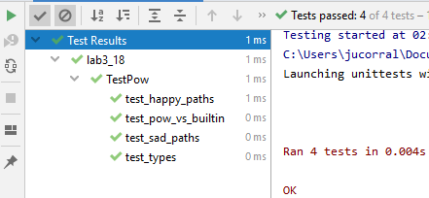

**19) Given the filecmp.cmp function,**

**Define a set of test cases that exercise the function (Remember Right BICEP)**

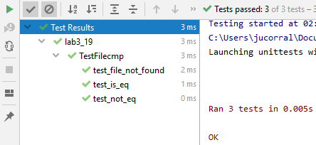

**20) Implement a class that manages a directory that is saved in a text file. The data saved includes:**

**a. Name**

**b. Email**

**c. Age**

**d. Country of Origin**

**The class should have capabilities to:**

* **Add new record**
* **Delete a record**
* **Look for a record by mail and age**
* **List on screen all records**

